- Install git.
Git –version
Download the git bash automatically gitbash alo installed
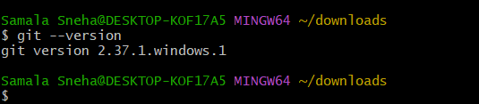

- Create a repo in github with README.md and .ignore file.
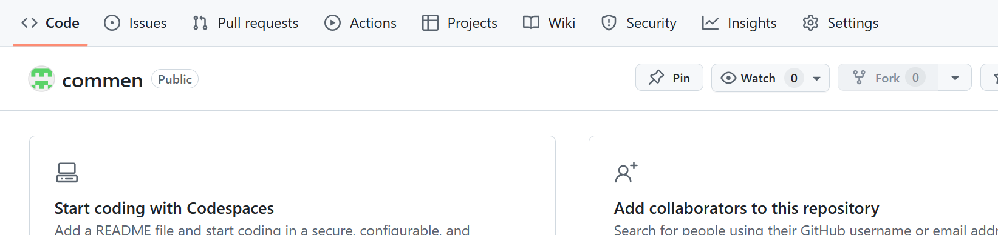
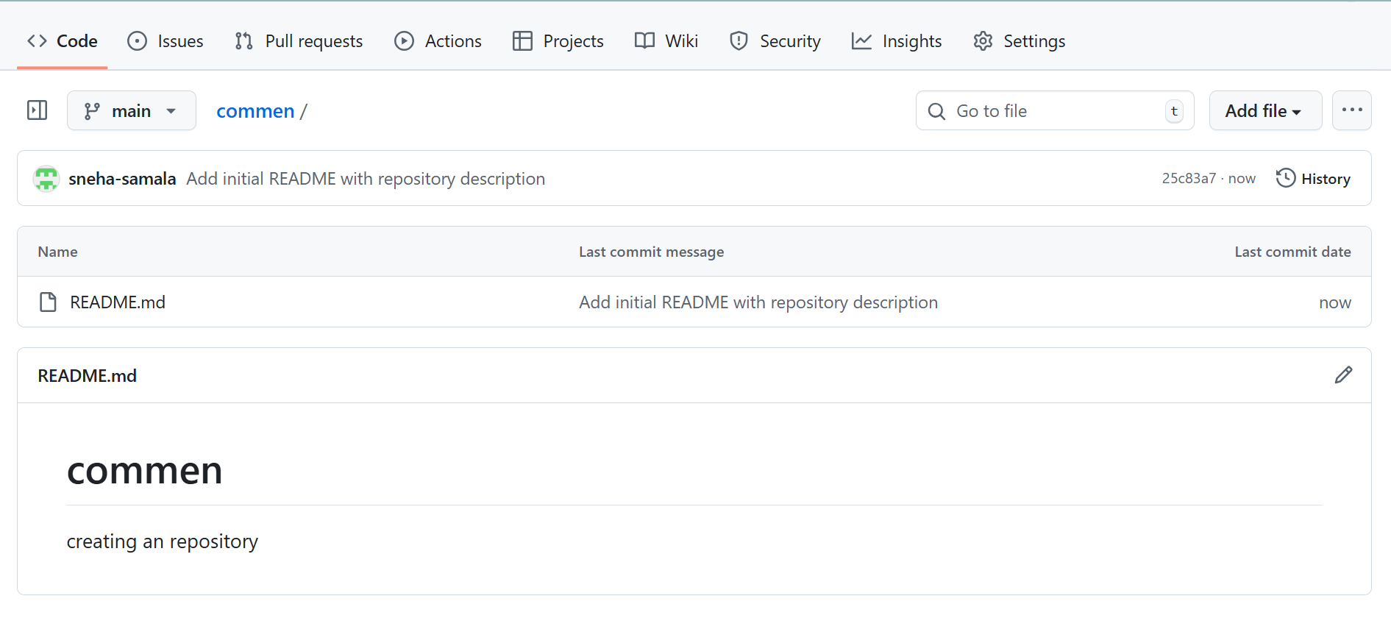
- Clone the created repo to local.
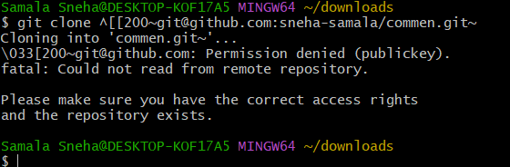

- Create two files in local repo.

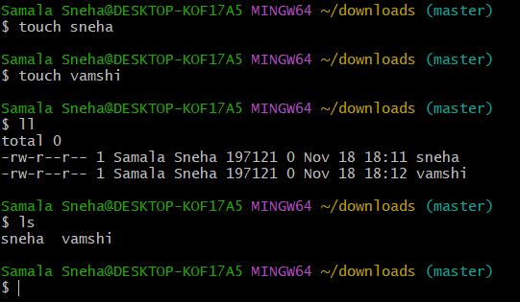
- Commit two files and push to central Repository.
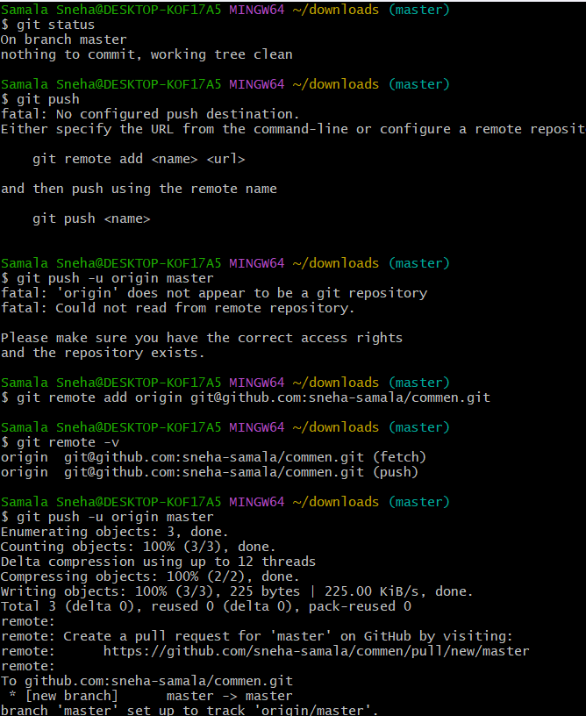
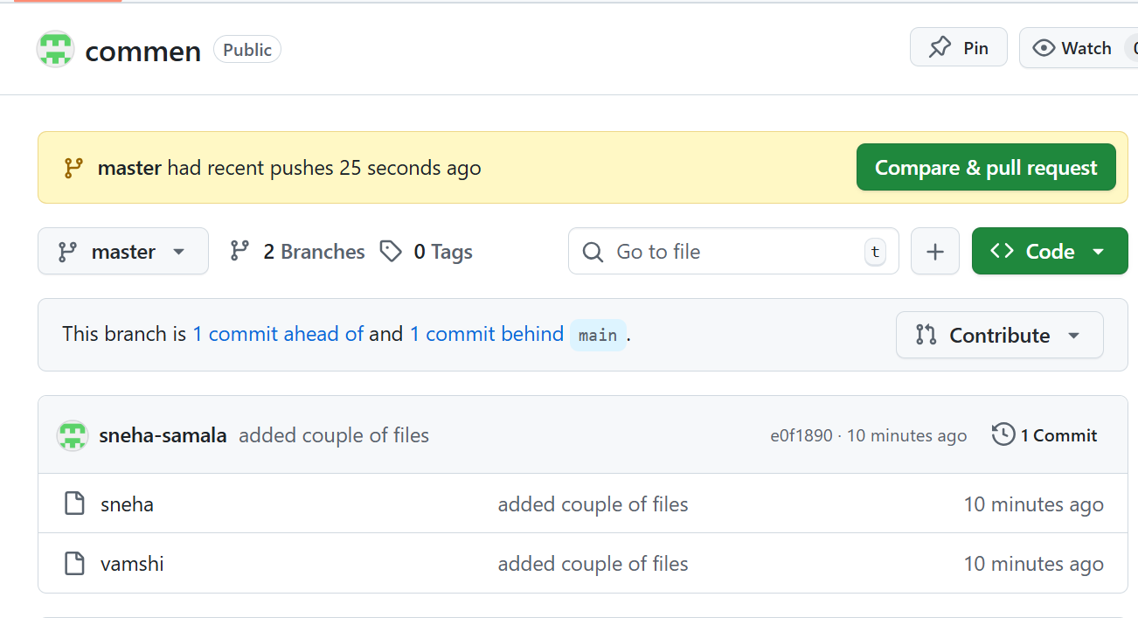
- Create a branch in local and create a sample file and push to central.
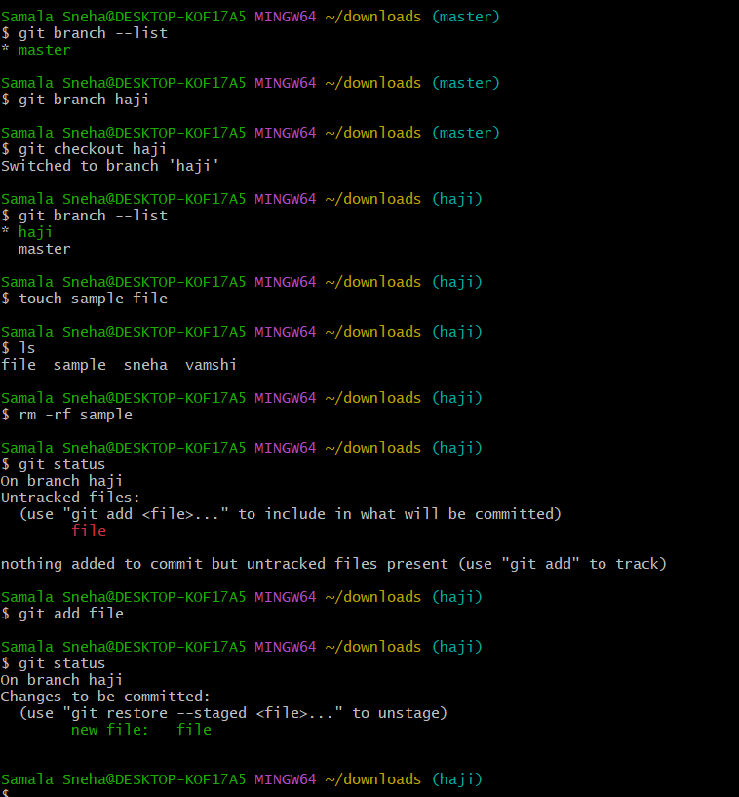
- Create a branch in github and clone that to local.
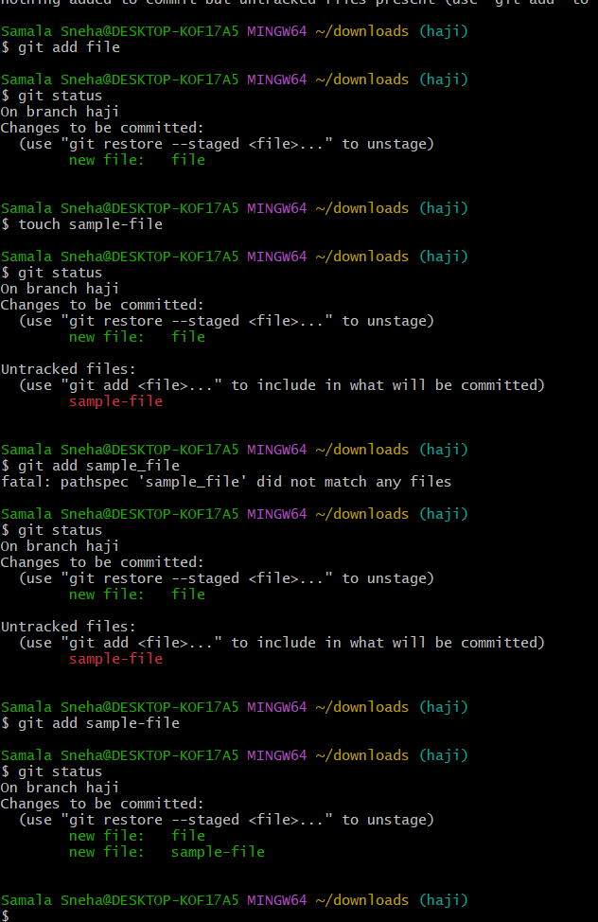
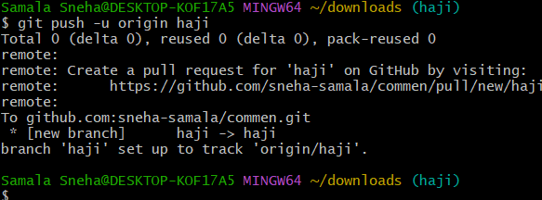
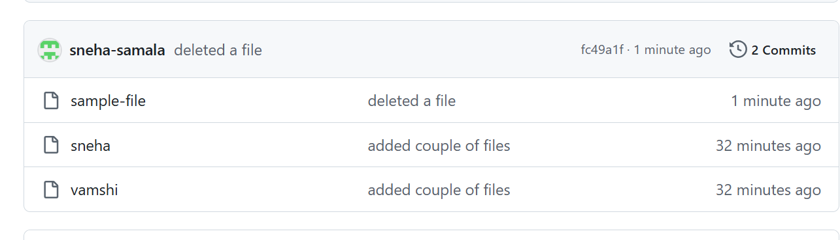
- Merge the created branch with master in git local.
- 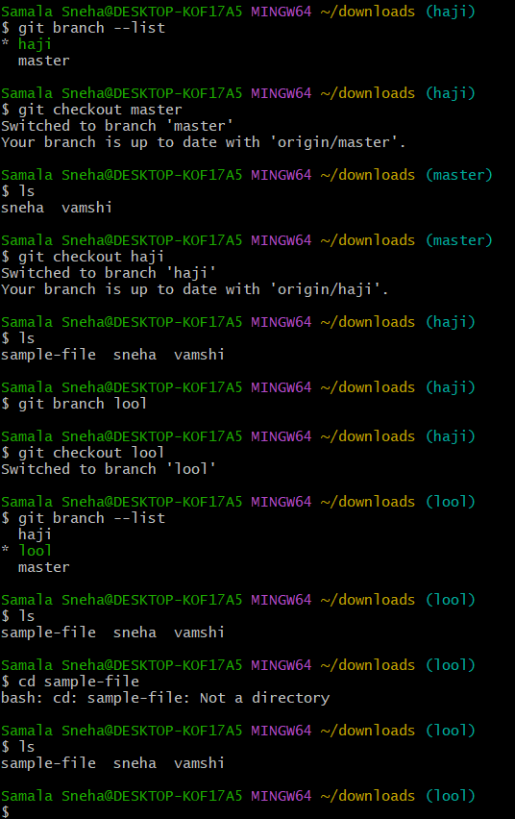 Merge the created branch with master in github by sending a pull request.
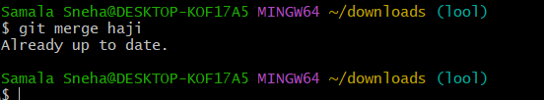
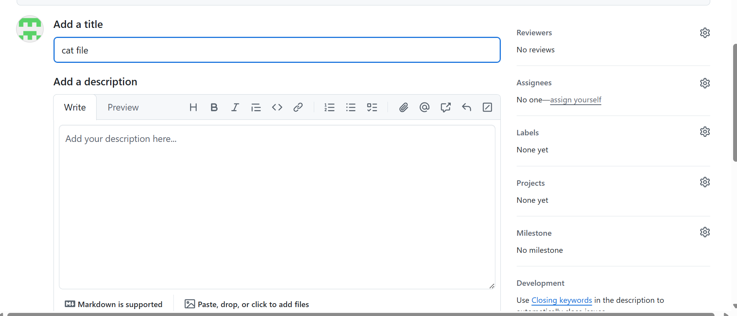

- Create a file in local and send that to branch in github.
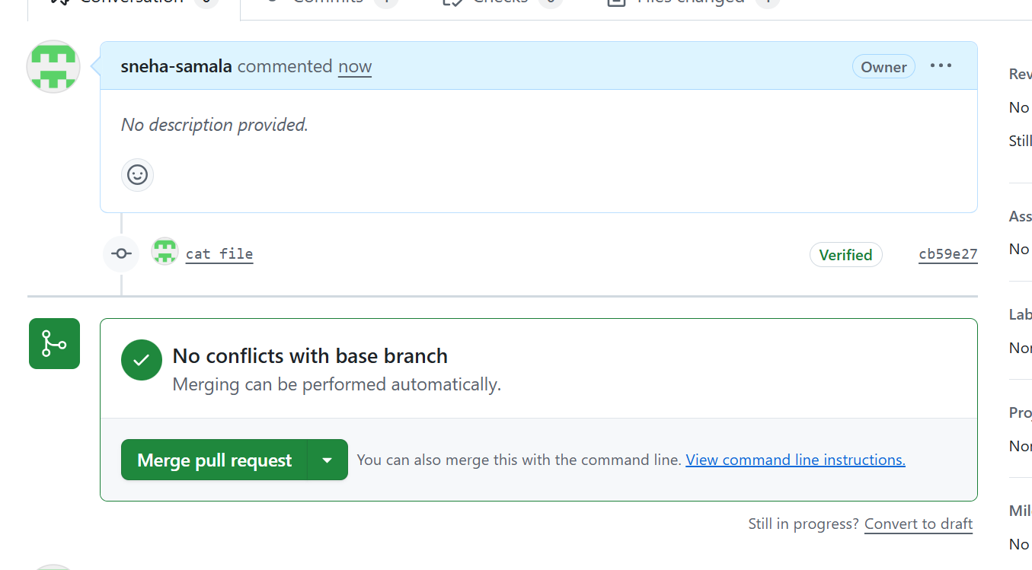
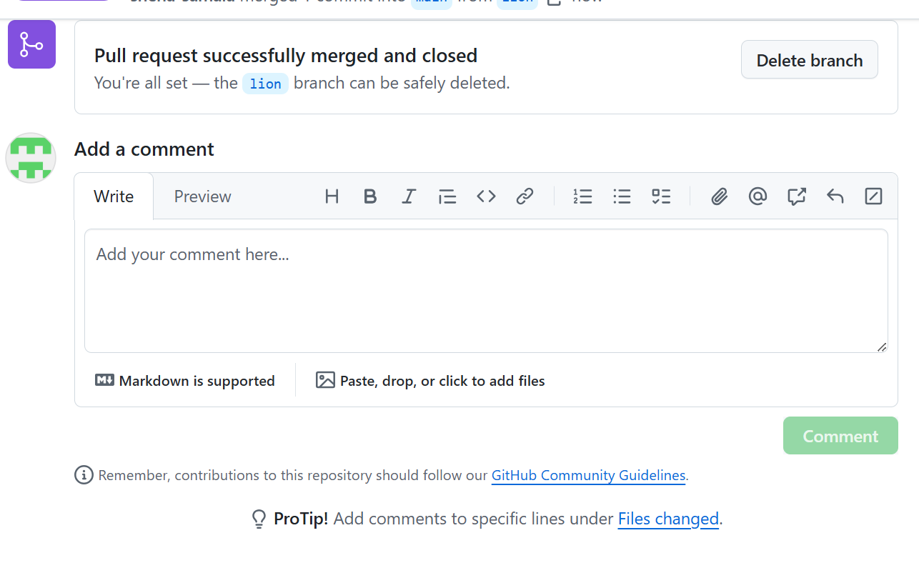
- Clone only a branch from github to local.
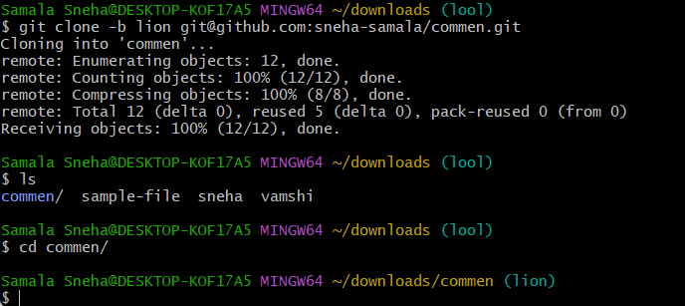

- Create a file with all passwords and make that untrackable with git.

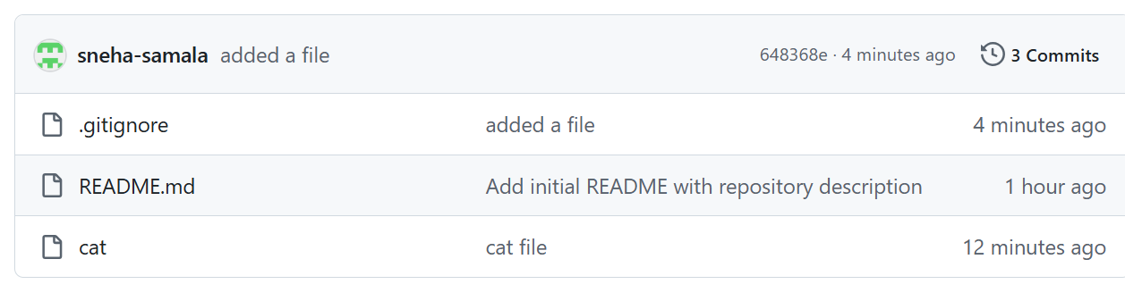
- Make a commit and make that commit reset without savings changes.
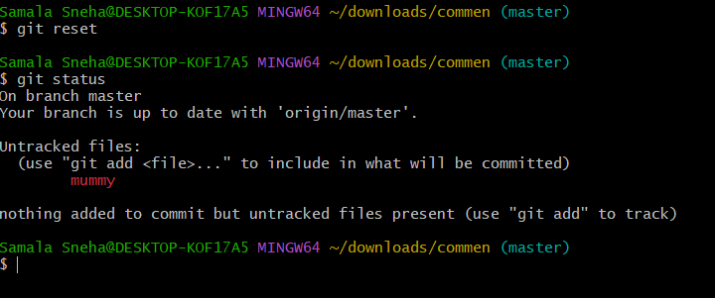
- Revert a commited commit to the older version.
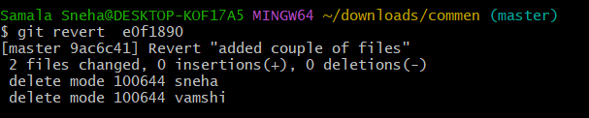
- Push a file to stash without savings the changes and work on another file.
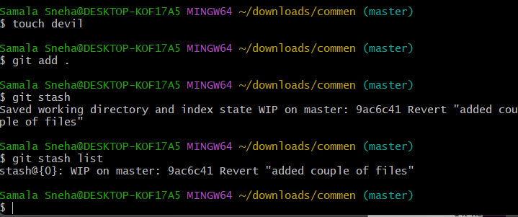
- Undo the stash file and start working on that again.
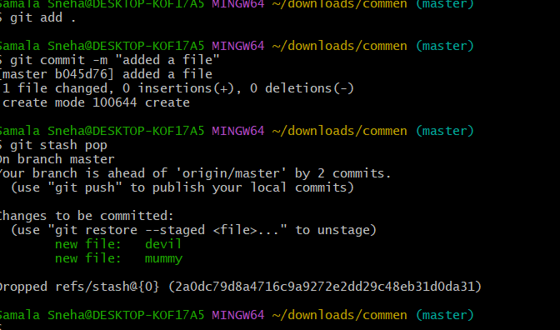
- Generate a ssh-keygen and configure into github.
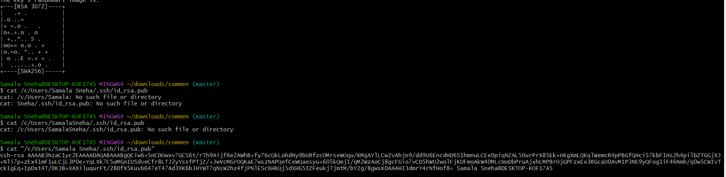
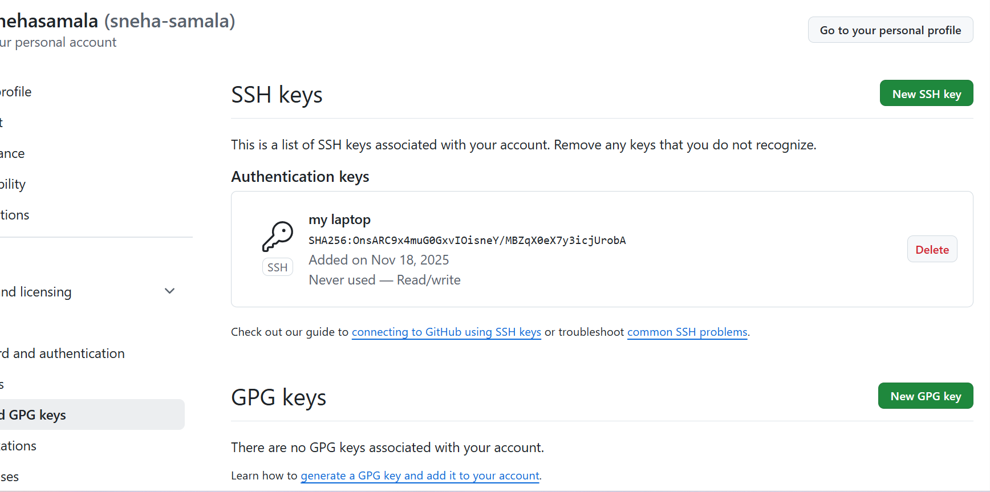
- Configure webhooks to github.

- Basic understanding of .git file.

Basic
understanding of .git file.
The .git folder is the core of your Git repository; it's the database where Git stores all the history, metadata, and configuration for your project. If you delete this folder, your project is no longer a Git repository, and you lose all your version history.
The folder is created when you run git init or git clone and is usually hidden.

- Check all the logs of git.
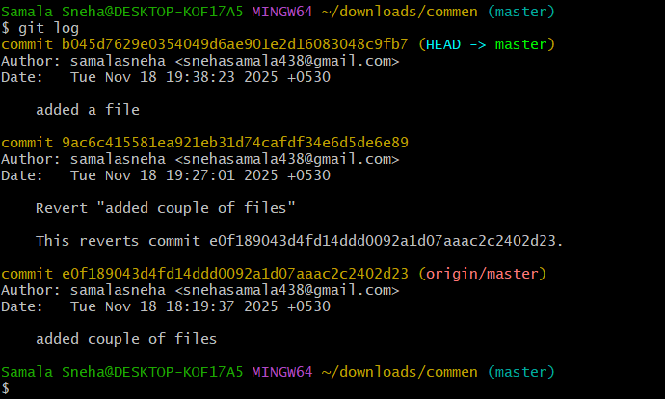
- Rename the commit message.
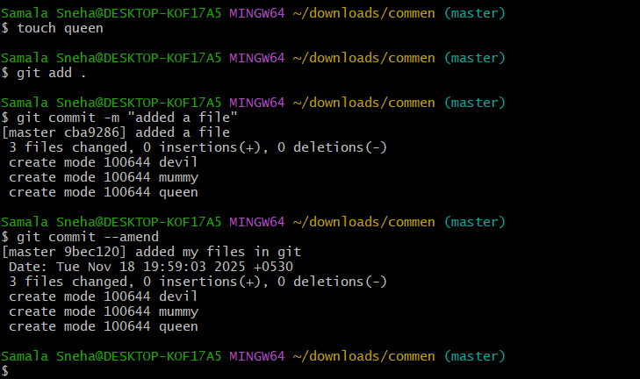
- Merge multiple commits into single commit.

